**TRAFFIC MANAGEMENT SYSTEM**

**PHASE – 4**

**DEVELOPMENT PART – 2**

**IoT TECHNOLOGY**

**INTRODUTION:**

* In this day & age, the conventional systems to manage urban mobility are proving incompetent. And there’s a growing need for an efficient traffic management system.
* Cities big and small are in dire need of technology-led digital solutions to manage & monitor traffic. They can help regulate heavy traffic, road blockages at signals & congested networks.
* An Internet of Things (IoT)-enabled intelligent traffic management system can solve pertinent issues by leveraging technologies like wireless connectivity & intelligent sensors. Considered a cornerstone of a smart city, they help improve the comfort and safety of drivers, passengers & pedestrians.

**Role of IoT in Smart City Traffic Management:**

With the pressing demand for advanced communication & network technologies, digitalization is the driving force that stimulates the implementation of smart traffic control using IoT capabilities.

It enables them to;

* Expand the capacity of city streets without having to build new roads.
* Optimize the traffic flow and keep the drivers safe. It would include cameras, sensors, and cellular technologies that automatically adjust traffic lights, expressway lanes, speed limits, and highway exit counters.
* Transmit accurate information about available parking spaces to citizens in real-time
* Collect data on congestion and improve traffic signaling to reduce blockages and optimize commute
* Locate incidents and report them to emergency rooms immediately with road sensors and video surveillance
* Employ real-time data feeds to ensure the streetlights turn dim or brighten up per the changing weather conditions and the onset of day and night

## Functioning of Traffic Monitoring System Using IoT Capabilities:

* This intelligent system comprises several components, including wireless sensors, RFID tags, and BLE beacons installed at the traffic signals to monitor the movement of vehicles.
* A real-time data analytics tool connects the Geographic Information System (GIS-enabled) digital roadmap with control rooms for real-time traffic monitoring.
* The smart traffic management system captures the images of vehicles at the signals using the digital image processing technique. This data is then transferred to the control room via wireless sensors.
* The system also leverages BLE beacons or RFID tags to track the movement of vehicles and keep traffic congestion in control, track down stolen vehicles and even clear the road for emergency vehicles that are installed with RFID readers.

## Application of IoT in Traffic Management

City governments can improve their operations & infrastructure by placing IoT sensors and tracking devices on roads and highways for recording, analyzing, and sharing data in real-time.

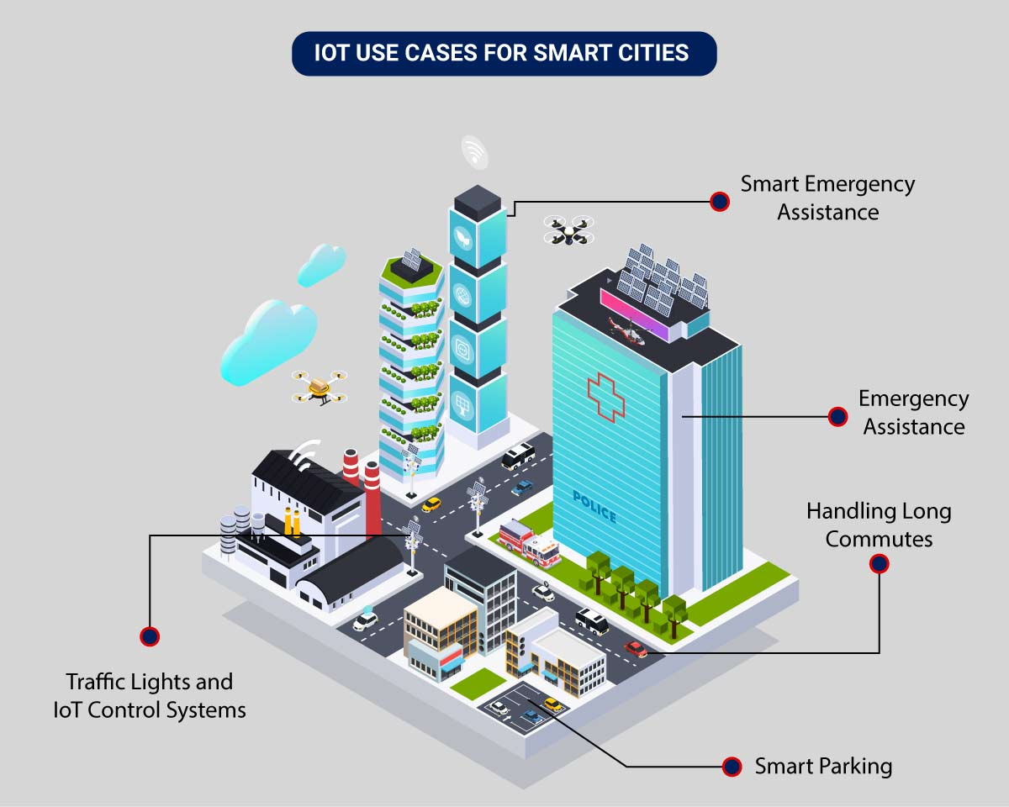

An intelligent traffic monitoring system using IoT capabilities has so many factors & use cases, including;

* **Traffic Lights and IoT Control Systems**: Smart traffic signals may look like a typical stoplight, yet they utilize an array of sensors to monitor real-time traffic. Usually, the goal is to help cars reduce the amount of time spent idle. And IoT technology enables the various signals to communicate with each other. This is while adapting to changing traffic conditions in real time. The outcome is less time spent in traffic jams and even reduced carbon emissions.
* **Parking Enabled through IoT**: Smart meters and mobile apps make on-street parking spaces easily accessible with instant notifications. Drivers receive alerts whenever a parking spot is available to reserve it instantly. The app gives easy directions to the parking spot with a convenient online payment option.
* **Emergency Assistance through IoT**: A traffic monitoring system using IoT technology enables emergency responders to speed up the care mechanism in case of accidents late at night or in isolated locations. The sensors on the road detect any accident, and the problem is immediately reported to the traffic management system. This request is passed on to relevant authorities to take corrective action. Emergency response personnel would include medical technicians, police officers, and fire departments for enhanced responsiveness and timely intervention.
* **Commute Assistance:**With every vehicle acting as an IoT sensor, a dedicated app can make suggestions, determine optimal routes & provide advance notice of accidents or traffic jams. Further, it can even suggest the best time to leave. It is all because of a robust algorithm that helps reduce driving time with intelligent traffic lights.

## Implementation of a Smart Traffic Management System – Key Elements

Whether municipalities want to improve their traffic management approach, expand public services, or upgrade existing infrastructure – it all starts with a smart city solution!

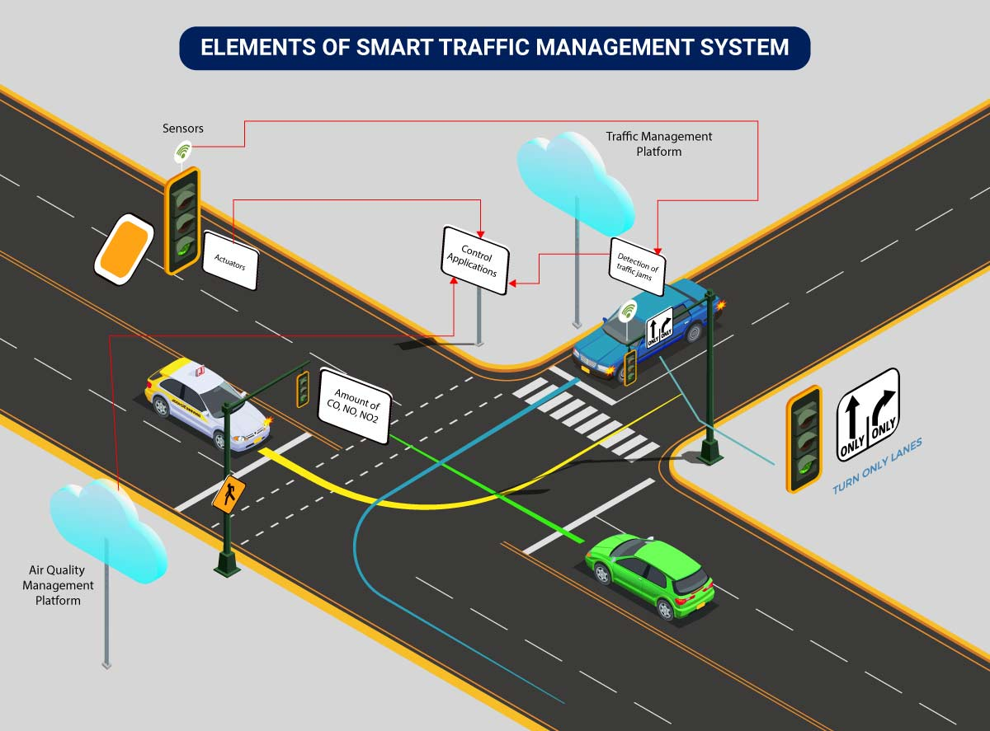

Here’s an implementation plan for building a scalable traffic control system using IoT capabilities:

A basic architecture that serves as a launchpad for feature enhancements and service upgrades will integrate the following components:

* **Sensors**for collecting data and sending it to a centralized cloud platform
* **Actuators**for physical devices to make necessary adjustments like – restricting the water supply in pipelines with leakages or dimming & brightening streetlights based on weather conditions.
* **Field gateways**to collect & compress data before moving it to a cloud platform.
* **Cloud gateways**enable secure data transfer between field gateways & the cloud storage of the traffic management system
* **A data lake**to store the raw, unstructured information before it is cleansed, processed, transformed & moved to a data warehouse for extracting actionable insights
* **Data warehouse**stores contextual information about connected objects and devices installed with sensors and actuators.
* **Data analytics**for analyzing the data from streetlight sensors on a centralized dashboard to adjust the intensity of lights
* **ML algorithms**to analyze traffic patterns & trends from historical data – stored in the data warehouse. The identified trends are then used to build predictive models for control apps. These apps modify the average vehicle speed to avoid congestion.
* **Rules**to enable actuators to automate the functioning & control of smart city objects and devices. These rules are manually defined to tell actuators what needs to be done to solve a specific problem.
* **User applications** that allow citizens to receive instant notifications in case of traffic jams and congested routes. Desktop user apps for control rooms send commands to actuators for altering traffic signals. It helps to relieve congestion and optimize routes.
* **Cross-solution integrations** with traffic lights or streetlight management systems. Control apps apply ML models or predefined rules to prompt appropriate output action if the air quality is poor.

Cities of all sizes can leverage this approach. Depending on the budgetary and procurement constraints, they can start small. It would be with solutions like – a littering offense ticketing system or a smart parking app. Later they can expand the range of services.

**Code for control the Traffic Lights:**

import time

class TrafficLight:

def __init__(self):

self.state = "red"

def change_state(self):

if self.state == "red":

self.state = "green"

elif self.state == "green":

self.state = "yellow"

elif self.state == "yellow":

self.state = "red"

def run(self):

while True:

print(f"Traffic light is {self.state}")

time.sleep(2) # Change the state every 2 seconds

self.change_state()

if __name__ == "__main__":

traffic_light = TrafficLight()

traffic_light.run()

This is a simple traffic light simulation. It starts with the red light and changes to green, yellow, and back to red in a loop with a 2-second interval for each state.

**Vehicles Detection in Traffic management system:**

Detecting vehicles in a traffic management system typically involves using computer vision and deep learning techniques. One popular framework for this task is YOLO (You Only Look Once).

**Code for Vehicles Detection :**

import cv2

import numpy as np

# Load YOLO

net = cv2.dnn.readNet("yolov3.weights", "yolov3.cfg")

layer_names = net.getLayerNames()

output_layers = [layer_names[i[0] - 1] for i in net.getUnconnectedOutLayers()]

# Load classes (COCO dataset has 80 classes)

classes = []

with open("coco.names", "r") as f:

classes = f.read().strip().split('\n')

# Video capture

cap = cv2.VideoCapture("traffic_video.mp4") # Replace with your video file

while True:

ret, frame = cap.read()

if not ret:

break

height, width, channels = frame.shape

# Detecting objects

blob = cv2.dnn.blobFromImage(frame, 0.00392, (416, 416), (0, 0, 0), True, crop=False)

net.setInput(blob)

outs = net.forward(output_layers)

# Information to display on the screen

class_ids = []

confidences = []

boxes = []

# Process detected objects

for out in outs:

for detection in out:

scores = detection[5:]

class_id = np.argmax(scores)

confidence = scores[class_id]

if confidence > 0.5: # Adjust the confidence threshold as needed

# Object detected

center_x = int(detection[0] * width)

center_y = int(detection[1] * height)

w = int(detection[2] * width)

h = int(detection[3] * height)

# Rectangle coordinates

x = int(center_x - w / 2)

y = int(center_y - h / 2)

boxes.append([x, y, w, h])

confidences.append(float(confidence))

class_ids.append(class_id)

# Apply non-maximum suppression to eliminate duplicate detections

indexes = cv2.dnn.NMSBoxes(boxes, confidences, 0.5, 0.4)

for i in range(len(boxes)):

if i in indexes:

x, y, w, h = boxes[i]

label = str(classes[class_ids[i]])

confidence = confidences[i]

# Draw a rectangle and label on the frame

color = (0, 255, 0) # Green color

cv2.rectangle(frame, (x, y), (x + w, y + h), color, 2)

cv2.putText(frame, f"{label} {confidence:.2f}", (x, y - 10), cv2.FONT_HERSHEY_SIMPLEX, 0.5, color, 2)

cv2.imshow("Vehicle Detection", frame)

if cv2.waitKey(1) & 0xFF == 27: # Press 'Esc' to exit

break

cap.release()

cv2.destroyAllWindows()

In this code, make sure you have the YOLO model files ("yolov3.weights" and "yolov3.cfg") and the class names file ("coco.names"). You should also replace "traffic_video.mp4" with the path to your video file. This code will detect vehicles in the video stream and draw bounding boxes around them. You can adjust the confidence threshold and other parameters to suit your specific needs.

## Advantages of a Smart Traffic Management System

Cleaner, greener, safer, and more accessible roads are a few benefits of implementing IoT and intelligent technology.

It helps with the following:

* Reducing traffic jams and accidents on the streets
* Ensuring immediate clearance for emergency vehicles
* Facilitating safer and shorter commute times
* Reducing congestion & energy consumption at intersections
* Offering significant productivity benefits with real-time monitoring of crucial infrastructures
* Reducing operating costs with efficient traffic management processes
* Ensuring compliance with the regulations for reducing the carbon footprint
* Saving billions of gallons of fuel wasted every year
* Accurate tracking & quick recovery of lost and stolen vehicles

**Conclusion:**

In conclusion, the Traffic Management System project represents a significant step forward in addressing the growing challenges associated with urban congestion and transportation efficiency. Through the implementation of innovative technologies, data analysis, and infrastructure improvements, this system aims to enhance the overall quality of life for residents and visitors in our cities. It has the potential to reduce traffic accidents, decrease travel times, lower carbon emissions, and promote a more sustainable and accessible urban environment.